Basics of NLP
Application of NLP
Search engine: user write text to search any information available on internet
Machine translation: language can be translated to any other language.
Categorization of data: data is categorized as per the type of information it consists.
Conversation systems: chatbots, voice agents like alexa or siri. Which interacts to human.
Spelling correction: automatically corrects spellings.
Types datasets – Structured and unstructured dataset.
Structured dataset: dataset having fixed number of dimension is called structured dataset. It consists data in well organised form. Eg. Data containing all information of emplyees, etc.
Unstructured dataset: data which do not have fixed number of dimensions, no structure. It can be in any form. Eg. Audio, video, image, text etc.
Text data:
eg. Social media: tweets, posts, comments.
Conversation: messages, emails, chats.
Article: news, blogs, transcripts.
In it, words are arranged in meaningful manner, written form of language, grammer and defined structure.
NLP is used to derive useful information from text data.
Regular expressions:
What are regular expression ?
Regular expressions are the combination of special characters which are also called pattrns. One key aspect is textual meaning. Example: “\d” is regular expression for numbers. Sometimes they are called wild card expression which can be used for searching, matching and parsing string. It is used for writing rule based information mining systems.
Application of regular expression:
Segmentation of words from sentences.
Segmentation of sentences from paragraph
Text cleaning – noice removal.
Information retrieval from text.
Types of regular expression
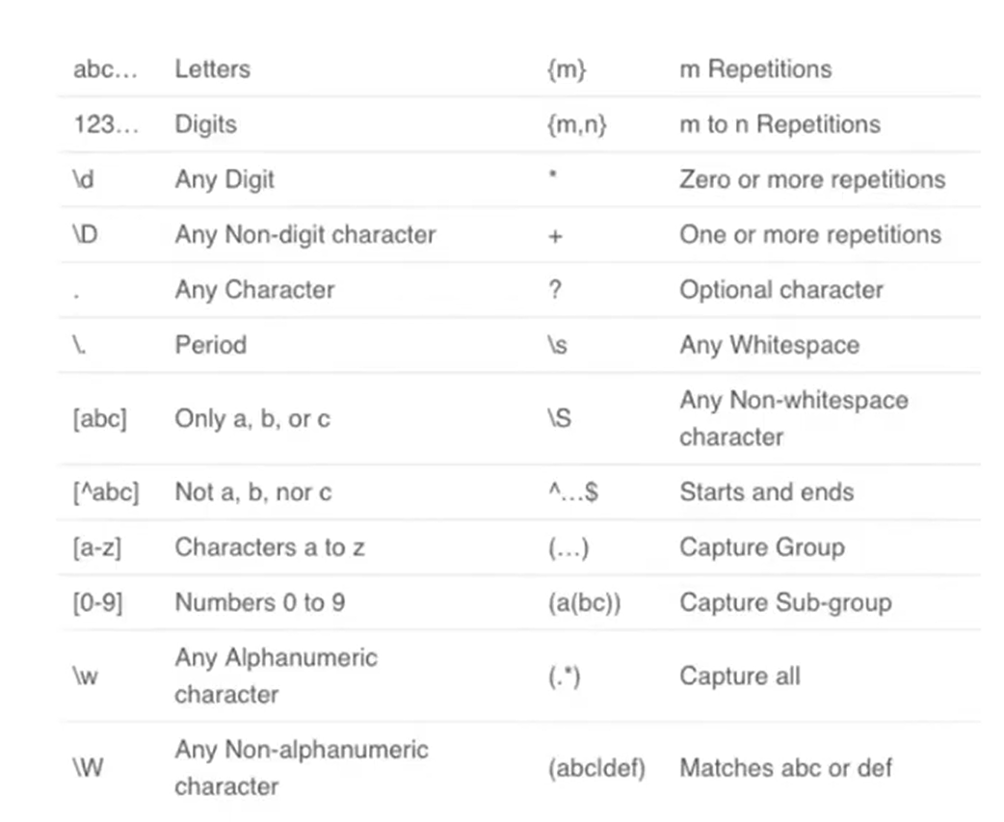
Regular expression function :
Match: finds the first occurrence of pattern in the string.
Search: locates the pattern in the strng.
Findall: find all occurrences of pattern in the string.
Sub: search and replace pattern in the string.
Split: split the text by the given regular expression pattern.
Implementing regular expression in python:
Code and output for match function:
re.match():
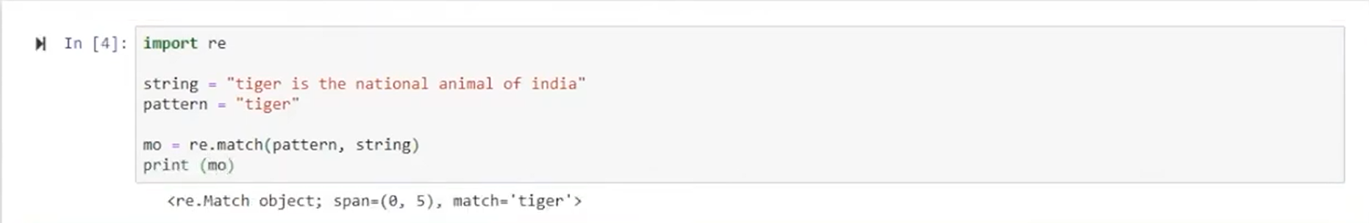
Here we imported Regular Expression as “import re”, then a text input is given and stored in string variable, then pattern which we are trying to find is given in variable pattern, then used re.match function with arguments as pattern and string to find pattern in string.out came as object, this is because pattern “tiger” is present in the string. re.match function finds pattern at startng position only.
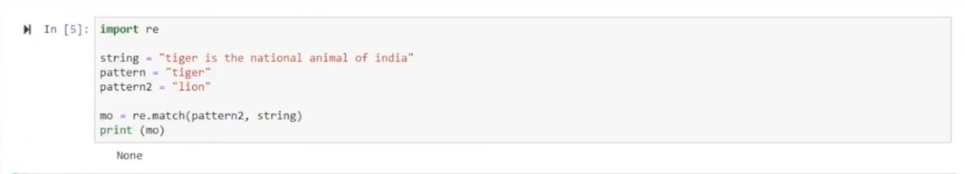
After some modification in same code, means if pattern is changed to “lion” and saved it to pattern2 variable then passed as arguments to re.match function the output is “None” because the pattern is not present in the input text.
re.search()
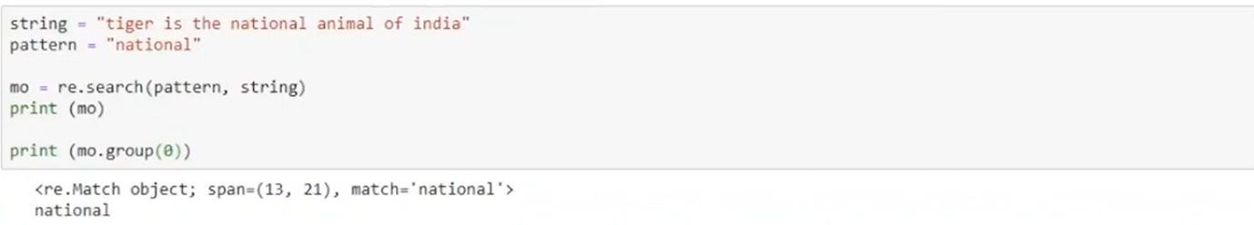
Here we used the same text as input and changed finding pattern to “national” and saved it to pattern variable, then used re.search function to find given pattern in the text and provided pattern and string as arguments, the output comes as object. The “.group(0)” function returns the entire substing that matched the regular expression pattern. re.search function is used to find pattern anywhere in the input.
Findall() and finiter()
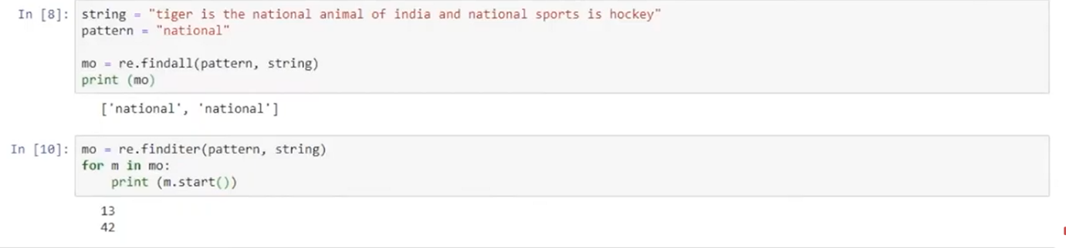
Here we gave different input and saved it to sting variable, pattern is same, then used re.findall function and passed string and pattern as arguments to find pattern in input data and saved it in variable “mo”, the output here is list because there are 2 variables means re.findall function finds all occrrences of pattern in input data.
re.finiter the input and pattern is same. It returns the indexes of pattern in the string. In this case our match object is an iterator, so we should perform iteration, this shows us index of pattern.
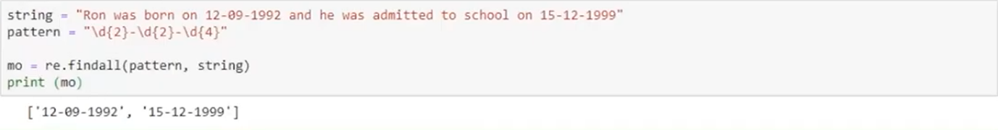
Here we changed the input and pattern to find dates in input data. The pattern to find dats is “\d{2}-\d{2}-\d{4}” it gives all occurences of dates as output.
re.sub()

here we directly used the re.sub function and passed pattern, what we have to change the pattern with and string in print to change pattern with another data, here we changed dates to Monday .
NLP techniques:
Corpus: collection of text documents
Tokens: smaller units of text.
Ngrams: combination of N words or characters together.
Example:
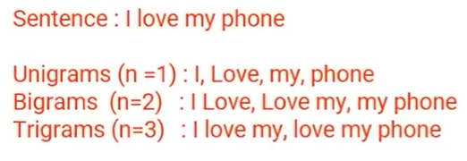
Tokenization: process of splitting text objects to small units.
Smaller units: words, numbers, symbols, ngrams, characters.
White space tokenizer/ Unigram tokenizer
Example
Regular expression tokenizer:
Example
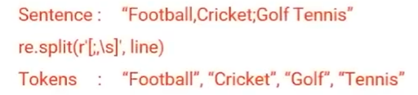
Normalization: converting a token to its base form.
Morpheme: base form of a word.
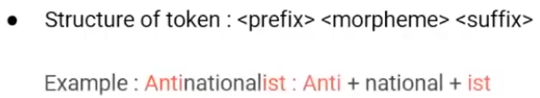
Helpful in reducing data dimensionality, text cleaning.
Types: stemming and lemmatization.
Stemming: elementary rule based process of removal of inflection form from a token. Output is stem of the word. Sometimes it may generate non-meaningful words.
Example
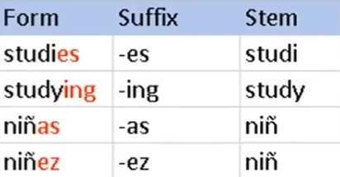
Lemmatization: systematic process for reducing a token to its lemma. It makes use of vocabulary, word structure, part-of-speech tags, and grammar relation.
Example:
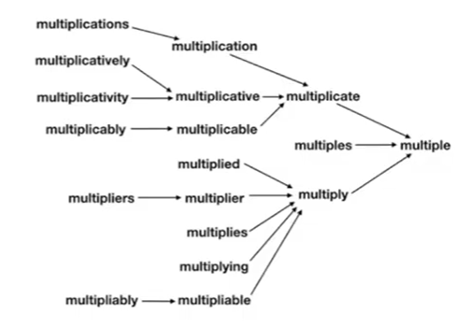
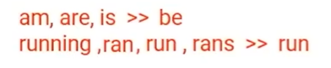
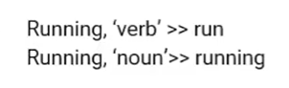
Syntax and grammar properties:
Part of speech tags: defines the systematic context and role of words in the sentence. Common POS tags are verbs, nouns, adjectives and adverbs. They are defined by their relationship with adjacent words.
Example:
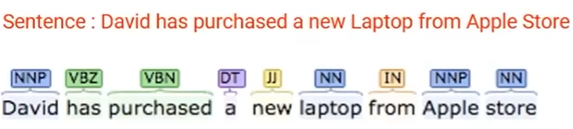
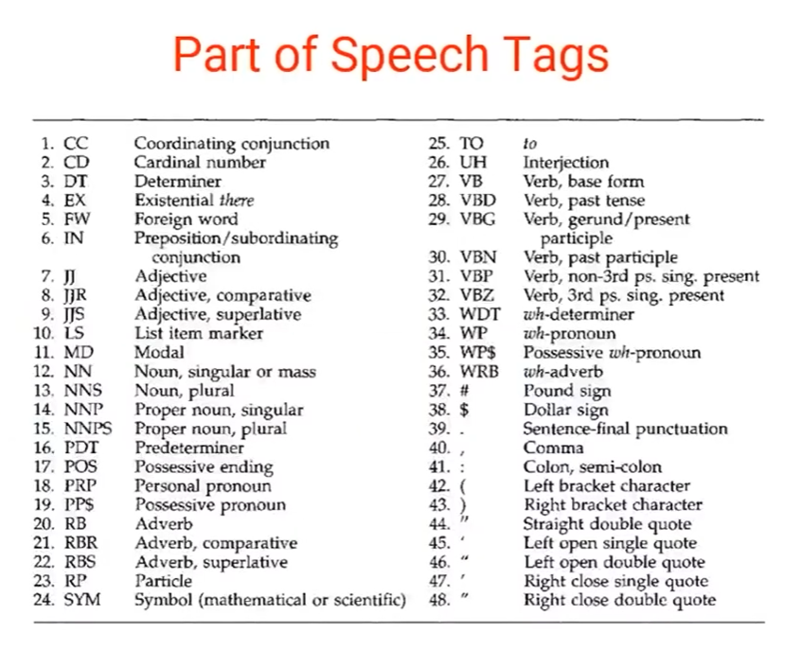
Uses:
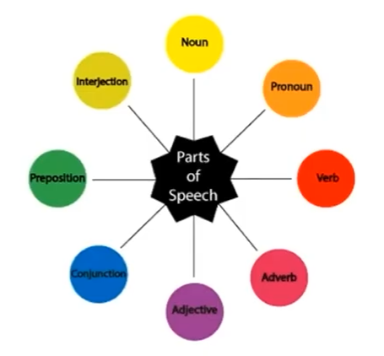
Text cleaning, feature engineering tasks, word sense ambiguation.
Example:
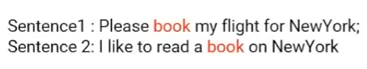
Constituency grammar:
Constituents: words/phrases/group of words.
Properties: part-of-speech tag/noun phrases/verb phrases.
Example:
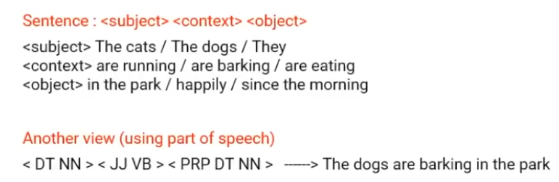
Dependency grammar: words of a sentence depends on which othe words.
Example: modifiers
Organise words according to their dependencies.
All the words are directly or indirectly linked to the root using links.
These dependencies represent relationship among the words in the sentence.
Example:
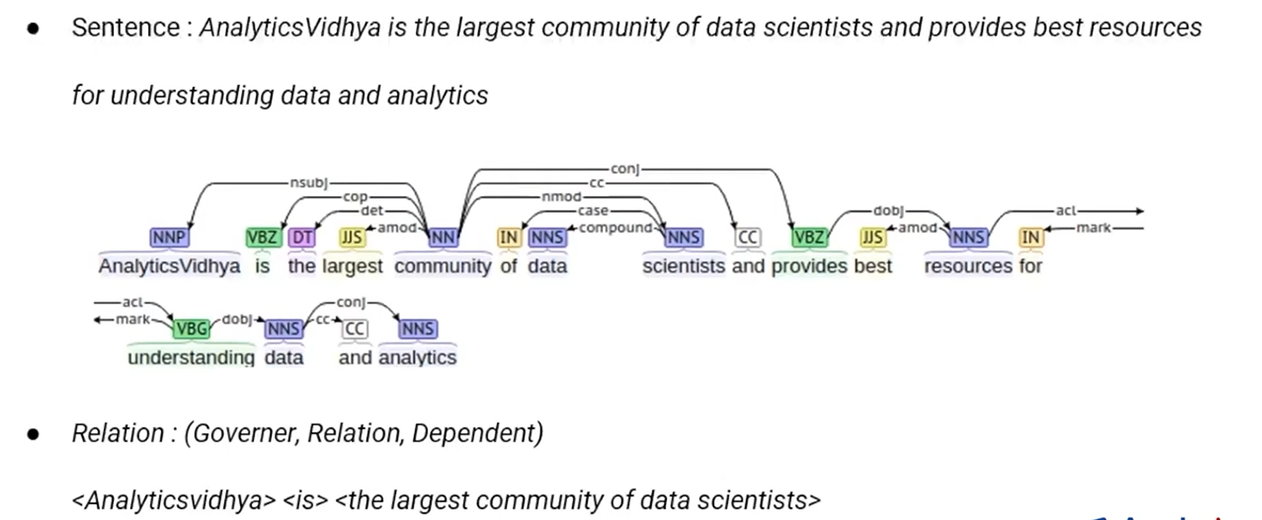
Uses:
Named entity recognition, question answering systems, conference resolution, text summarization, text classification.
Implementing text preprocessing using NLTK
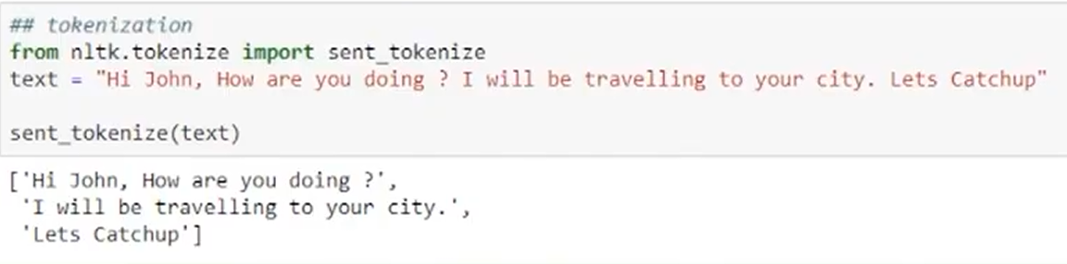
In this we imported sent_tokenize from tokenization which tokenizes 1 full sentence, we gave input text to a variable and used sent_tokenization function passed text as argument to tokenize. The output generated is list(python list) of sentnces.
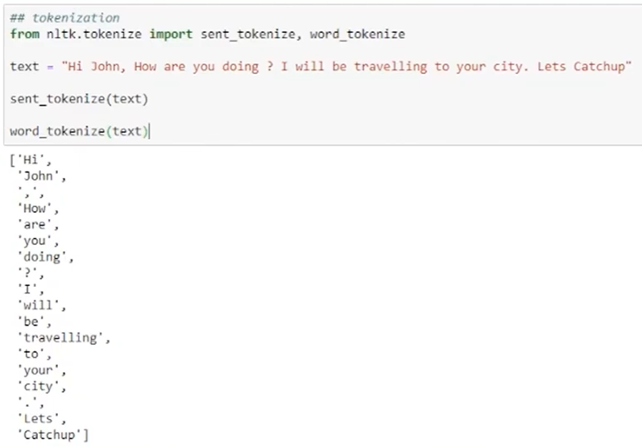
In this we modified the same code to do word tokenization. Imported word_tokenize from tokenization, used same input and then used word_tokenize function passed text as argument which tokenizes input to words. The output is list of words in input.
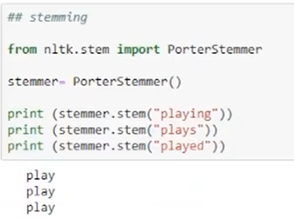
In this code we imported PorterStemmer from nltk.stem to perform stemming, saved PorterStemmer in a variable and in stemmer.stem function passed input text data as argument to stem and directly used in print statement. The output is root form of word.
Sometimes it makes mistake for example:
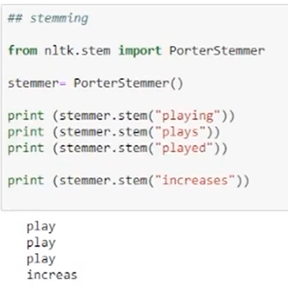
In the same code we gave word “Incrrases” for stemming but it gave wrong output as “Increas”.
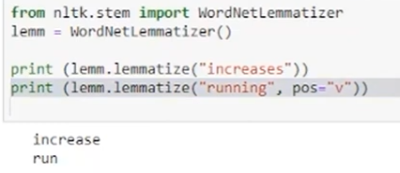
In this we imported WordNetLemmatizer from nltk.stem for lemmatizin input. We use lemm.lemmatize function passed input text and part of speech text as argument to lemmatize and used the function directly in print statement. The output is lemmatized word of input text data.
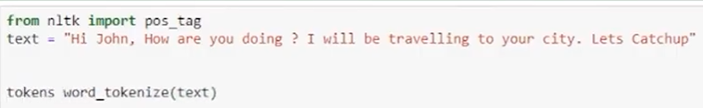
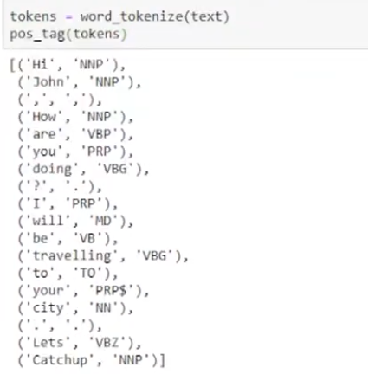
In this we imported pos_tag from nltk, saved input text in variable, tekens word_tokenizer function passed input text as argument to perform word tokenization and saved it in variable, in pos_tag function passed stored word tokenized data to get part-of-speech tages. The output is words with its part-of-speech tag.
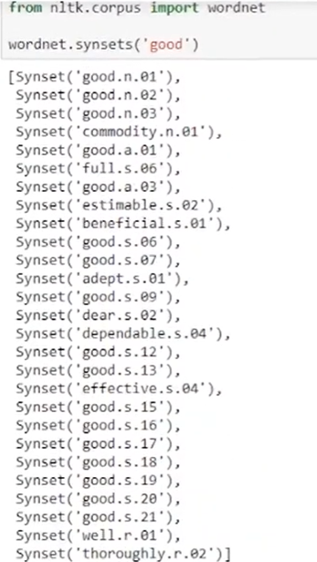
In this imported wordnet from nltk.corpus, in wordnet.synsets function passed input text data as argument to find synonym of the input data . the output is synonym word of the input.
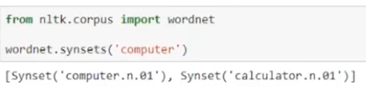
Here changed the input data to get synonym.

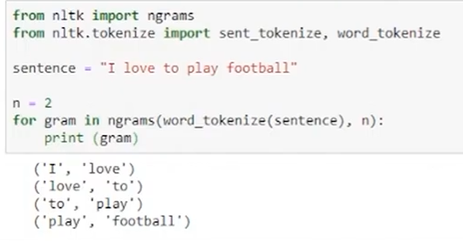
Here imported ngrams from nltk and sent_tokenizer, word_tokenizer from nltk.tokenizer, saved input data in variable, gave value to print ngrams wrote loop to generate ngrams also passed word_tokenizer function having input data as argument to it as argument and printed ngrams. The output is ngrmas of the value you pass. Here the valu is 2 so the output is bigrams.

